Project Initialization and Planning Phase

Team ID | MCA
Project Name | Smartphone Usage & Addiction Analysis
Maximum Marks | 3 Marks

Define Problem Statements (Customer Problem Statement Template):

The organization needs to understand why 5,308 of its 7,500 users (70.77%) are classified as addicted to smartphone usage, and which factors — screen-time behavior, lifestyle habits, stress, or demographic characteristics — most strongly correspond with that classification. Without this understanding, product and research teams cannot prioritize well-being feature investment or design targeted digital-health interventions.
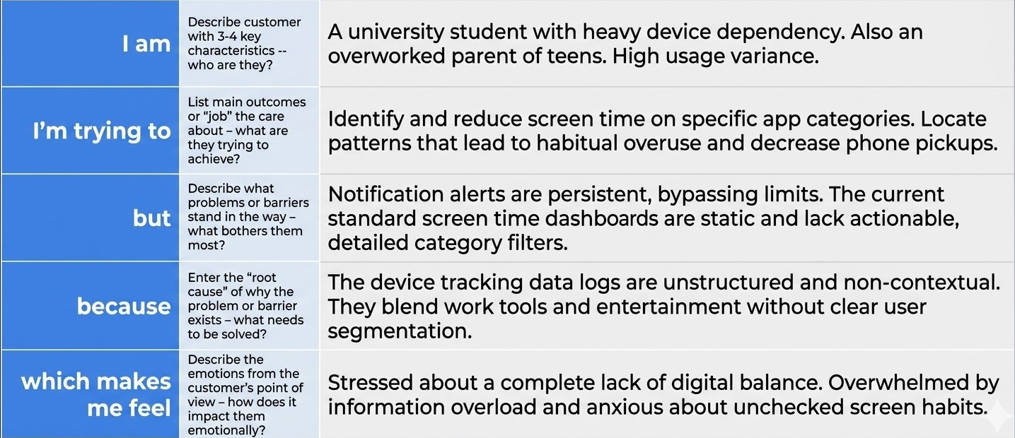
Example:
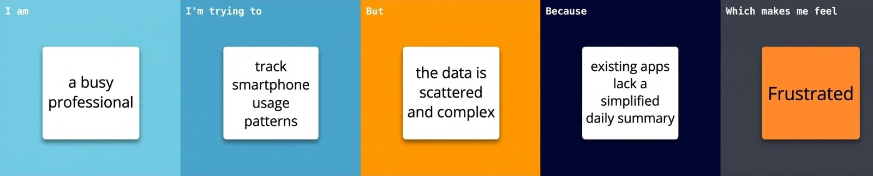

Problem Statement (PS) | I am (Customer) | I’m trying to | But | Because | Which makes me feel
PS-1 | A college student who uses a smartphone heavily every day | Cut down my screen time and sleep well without hurting my studies | I can’t tell which habits, such as social media, gaming or notifications, affect my sleep and studies the most | My phone only shows raw daily totals, with no comparison to other users and no link to sleep or study impact | Guilty and out of control
PS-2 | A working professional who uses my phone for both work and staying in touch | Stay focused during work hours while keeping up with messages and apps | Constant notifications and frequent app opens keep pulling me away from my work | I don’t know what level of notifications and app opens is normal, or how it relates to my stress and work hours | Stressed and distracted
PS-3 | A parent of a school-going or college-going child | Judge whether my child’s screen time is healthy or has turned into an addiction | I have no clear benchmark for what counts as addicted use for my child’s age and gender | Usage data is raw and is not grouped by age group, gender or addiction level | Worried and helpless
PS-4 | A college counsellor responsible for students’ digital well-being | Find which age groups, genders and stress levels are most at risk of smartphone addiction | I can’t quickly spot patterns or the factors that drive addiction in large usage records | The data sits in raw tables, with no interactive view to filter, compare and find key drivers | Overwhelmed and unsure where to focus

Project Overview
This project analyses smartphone usage behaviour through an interactive Power BI dashboard (smartphone_usage.pbix). The data model is a single table of user-level records covering age and gender, daily and weekend screen time, social media, gaming and work/study hours, sleep hours, notifications and app opens per day, stress level, academic/work impact, and addiction level and status, along with a derived age group. The problem statements above reflect the questions the dashboard is built to answer. The report has five pages:
Dashboard Page | What it shows
KPI | Summary cards showing the user count and the averages of age, daily and weekend screen time, social media, gaming and work/study hours, sleep hours, notifications and app opens per day.
Visualizations | Average daily screen time by gender and by age group; daily screen time vs sleep hours (scatter); addicted vs non-addicted users; users by addiction level; average gaming vs social media hours.
Page 2 | Addiction-level filter; sleep hours by addiction level; weekend screen time by addicted status; app opens by stress level; user share by age group and by addiction level; screen time by gender.
Report 1 | Filters for addiction level and age group; work/study hours by academic/work impact; weekend screen time by addiction level and by age group; a decomposition tree that breaks users down by age group, gender, stress level, addiction level and academic/work impact.
Report 2 | A key-influencers analysis of what drives addicted status (screen time, social media, gaming, notifications, age group); stress-level split; sleep hours by age group; social media hours by addiction level; high screen-time user split; gender and stress filters.

